## **CP5805 – Assessment 2B: Week 2 reflective journal**

**Task 1**

The condition action table is:

|  |  |
| --- | --- |
| Condition | Action |
| UV index < 3 | Display “low risk” |
| UV index >= 3 AND UV index < 6 | Display “moderate risk” |
| UV index >= 6 AND UV index < 8 | Display “high risk” |
| UV index >= 8 AND UV index < 11 | Display “very high risk” |
| UV index >= 11 | Display “extreme risk” |

**Task 2**

Flowchart

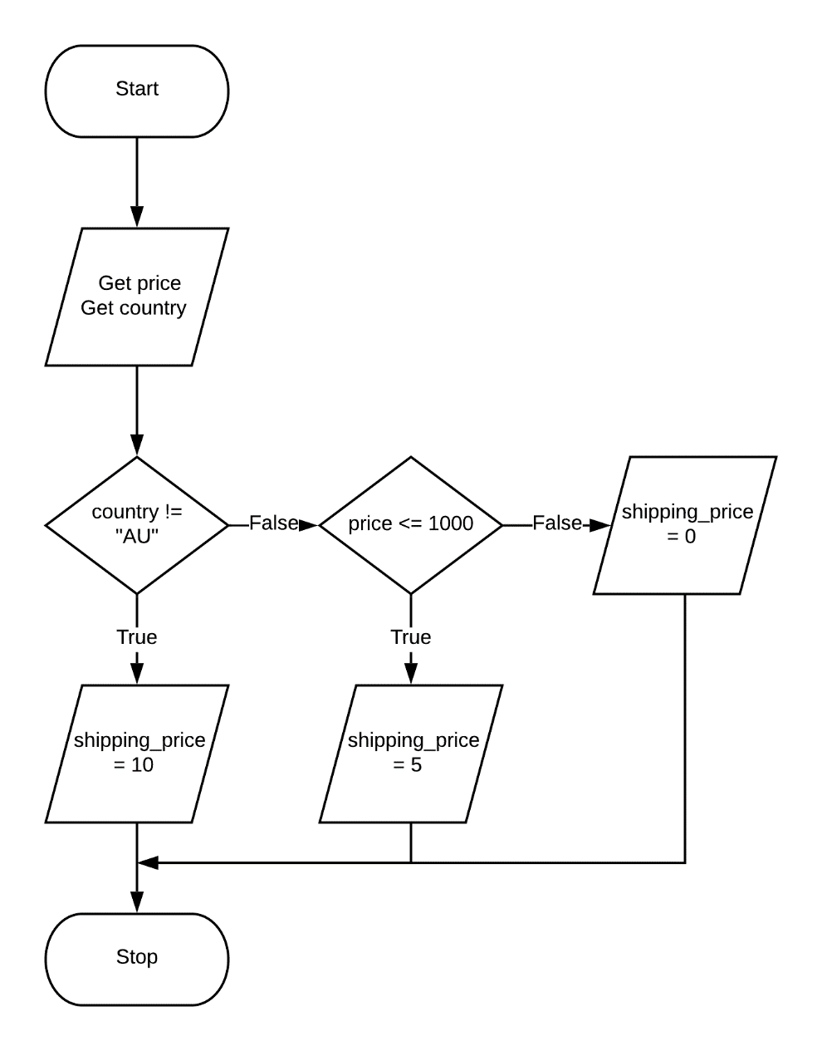

Example pseudocode solution

if country == “AU”

if price > 1000

shipping_price = 0

otherwise

shipping_price = 5

otherwise

shipping_price = 10

**Task 3**

A. temperature < 40 OR age > 70

|  |  |  |
| --- | --- | --- |
| LHS | RHS | LHS $∨$ RHS |
| True | False | True |
|  |  |  |

B. NOT (price > 1000 AND temperature < 30)

|  |  |  |  |
| --- | --- | --- | --- |
| LHS | RHS | LHS $∧$ RHS | $¬$ (LHS $∧$ RHS) |
| False | True | False | True |
|  |  |  |  |

C. temperature > 37 AND age < 12 OR price < 1000

let i = temperature > 37; ii = age < 12; iii = price < 1000

|  |  |  |  |  |
| --- | --- | --- | --- | --- |
| i | ii | i $∧$ ii | iii | i $∧$ ii $∨$ iii |
| False | False | False | True | True |

**Task 4**

find_max(data):

max = data[0]

for each item in data

if item > max then

max = item

otherwise

max = max

return max